Exercise: Basic Linux & Bash commands  
Instructions:

1. Create a file friends.txt with a list of names of three of your friends on separate lines.

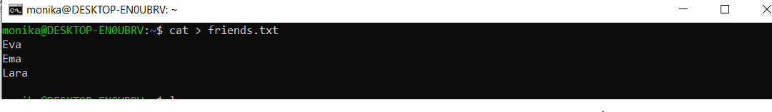

Cat > creates a new file, after the file is created we enter the name of the files (friends) and press control d to save.

1. Display the contents of friends.txt on the console.

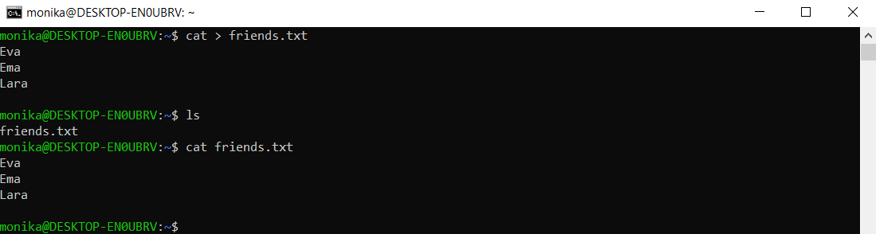

ls – we list all files and directories and than we enter cat (name of the file) we want to display, in our case : cat friends.txt

1. Rename file friends.txt to bestfriends.txt

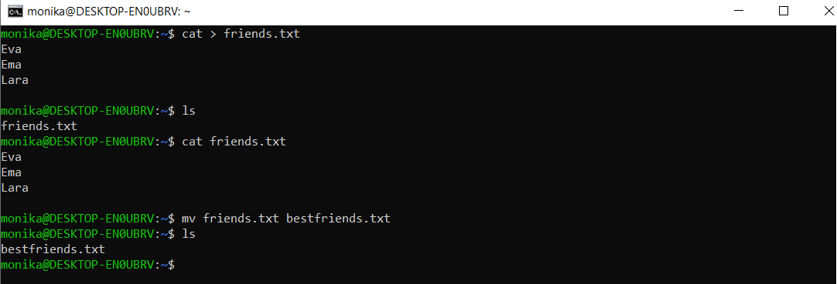

mv command is used to rename the file, after we hit enter we can check with ls to make sure the new name is correct.

1. Make a copy of bestfriends.txt under the name sysadmins.txt

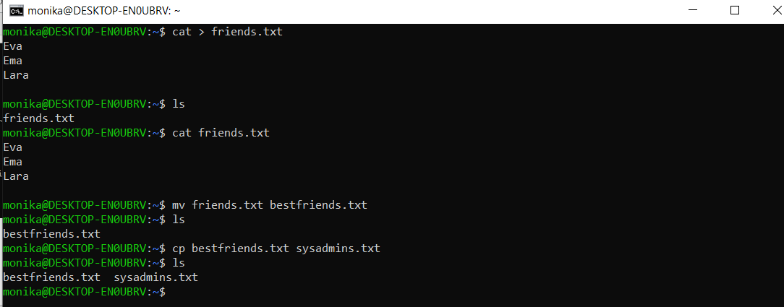

Cp command is used to copy the file   
we have to enter the name of the file we want to copy and the name of the new file   
e.g. cp bestfriends.txt sysadmins.txt  
next step is listing again and we can see the two files in the directory, meaning that the coping was successful.

1. List all files whose name begins with letter 'b' and ends with extension txt.

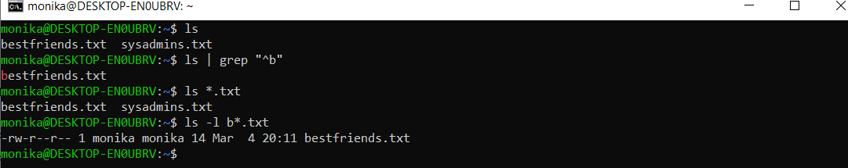

-To find the files starting with the letter b we can use the command grep   
first we list ls | grep and specify that the file begins with letter b “^b”

-We can also use ls \*.txt to filter all files that end with .txt

-Or we can be more specific and check the starting letter b and ending .txt   
ls –l b\*.txt

1. Write a command that will tell you how many bytes are taken up by file sysadmins.txt

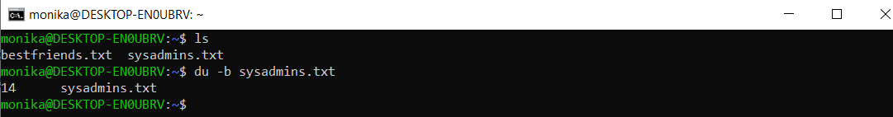

Du command means disk usage and –b means bytes  
this way we are checking the disk usage in bytes from the file sysadmins.txt

1. Create file cars.txt with a list of 5 brands of cars on separate lines.

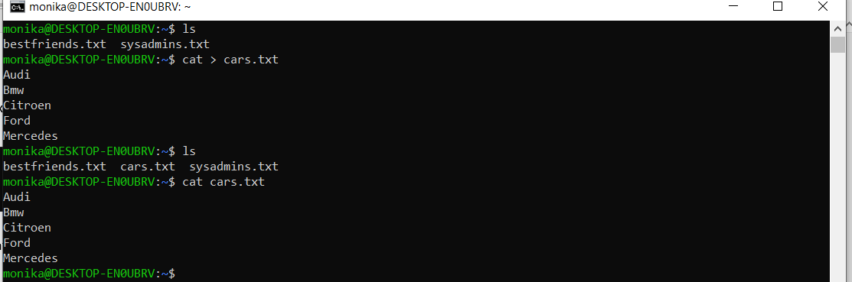

We use cat > to create the new file cars.txt and we enter 5 brands of cars  
Ls to check that the file is created and  
Cat cars.txt to view the file that we have created

1. Check how many bytes are taken up by the file.

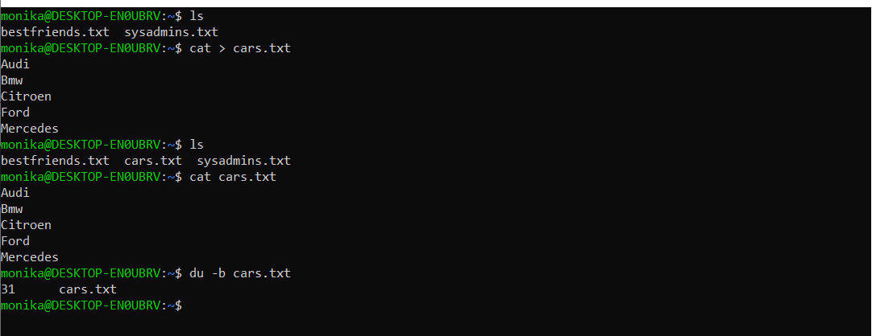  
du –b cars.txt means disk usage in bytes from file cars.txt

1. Copy the file cars.txt into directory /tmp

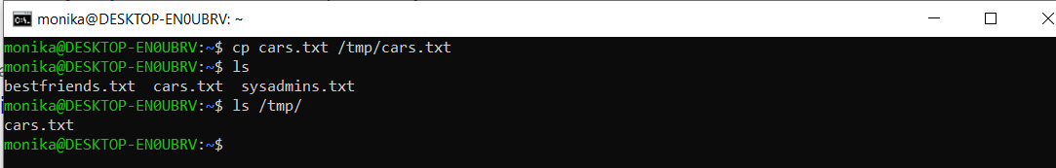  
cp cars.txt /tmp/cars.txt   
this means we are coping the cars.txt file into the temporary directory(tmp) by the same name cars.txt

10. List all files with extension \*.txt in directory /tmp and verify that the file was copied properly.

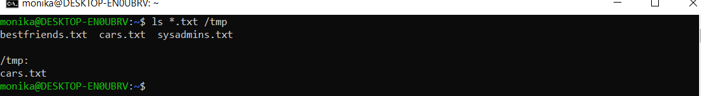

Ls \*txt /tmp   
this way we are checking all the .txt files and in the next line we are can see the file that was already copied to the tmp directory

11.Without leaving your home directory rename file cars.txt located in /tmp to vehicles.txt in /tmp

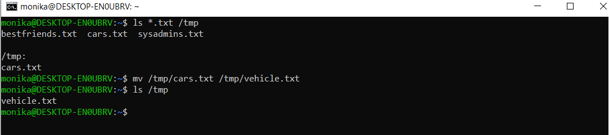

Using mv again to rename the file but this time we are making the changes into the/tmp directory.

12. Display the contents of /etc/passwd file on the screen interactively (so you can search, scroll up and down)

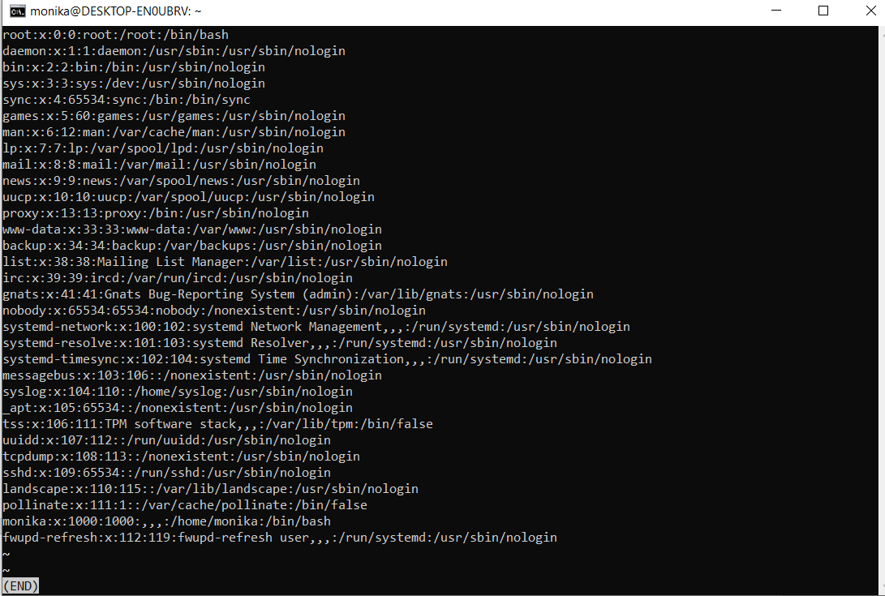

Less /etc/passwd   
Less is used to display all the opened files, after we hit enter we can scroll up and down or search by typing something. If we want to exit we can press q on the keyboard.